Etoys ^{3 Grid Games} Tic Tac Toe

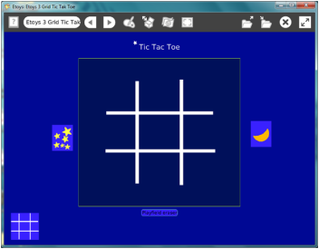

Making Grid Games with Etoys
Advice: First, read all the way through this project outline. It is good practice to plan before starting to program. By reading the whole plan you will see how your earlier decisions and later decisions fit together. You will be making many decisions and informed decisions are best. Step two: plan

Planning:
Sketch: title, game board, number of players, kinds of game pieces , motion, color scheme

Getting Started
The aqua color refers to helpful Quick Guides in Etoys; open them by clicking the question mark.

Game board and pieces: Use the Paint Tools to paint the game board design. Keep it.
Use a new Paint Tool to paint each kind of game piece that players will need. Click keep. Use a new Paint Tool for each kind of piece.

Adding Action
Paper and pencil game pieces don’t move so adding motion adds extra interest to your game and uses your programming knowledge to advantage. Click the Halo Handles Viewer icon to open a Viewer for a game piece. Make a script for the pieces that you want to move. Use the Forward by and turn by Script Tiles. Control the amount of motion by changing the numbers in the script.

Providing pieces for the game is easy, no matter how many pieces are needed. Go to Supplies and select the Object Catalog. Click on the Connectors tab. Drag out Maker Buttons, one for each kind of piece. Put the game board on a Maker Button. Use the Resize handle of the finished Maker Button to make it smaller. Game boards from the small Maker Button will be the original size not the smaller size.

Start a script ticking and pick up the game piece with the Halo’s Pick up handle. This can be tricky if the action is fast. Put the piece on a Maker Button. Copies will be in motion when played on the board.

Create a Game Arena and Reset
Game Arena: Open Supplies and select a Playfield. Make the Playfield the best size for your game board. Leave room outside of the Playfield for the supply of game pieces, the title and the reset button.

Reset: Open a Viewer for the Playfield, click on basic to open the category menu. Select collections from the menu. Create a script outside of the playfield with the tile: playfield remove all. Move all Maker buttons outside of the Playfield. Caution: the remove all command removes everything that is on the Playfield. Removed objects will not be in the Trash can, they are gone.

Test the reset script by putting a copy of a game piece on the playfield and clicking the script’s yellow exclamation point to run the script one time. This script should be set at normal, not ticking or paused.

Use the reset script’s white Menu and select: button fires a script. Put the new button outside of the playfield. Collapse the script.

Final Details
Title: Open Supplies and click on Text. Highlight the box and type the new title for your game. Change the font style and size to fit your design plan.

Color Scheme: Use the magenta paint tool in the Halo Handles for the World, Playfield, Maker Buttons, Text, and the Reset button to change their colors.

Check the spelling
Arrange the game pieces for player’s convenience
Make it look right
Collapse the Viewer tabs
Throw away the Trash can
Keep the project http://etoysillinois.org/library?sl=2152
Play the game
Enjoy!

